South Somerset Behaviour Partnership

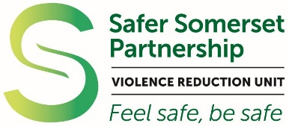

Somerset Violence Reduction Unit

www.somerset.gov.uk/vru
Multi agency unit that aims to reduce harm to individuals and the community through public health approaches to violence reduction.

For more information
Project Manager, Clare Stuart: c.stuart@somerset.gov.uk
VRU Sgt Ben Saville: ben.saville@avonandsomerset.police.uk

Schools Charter

Secondary Schools Programme

